10. Create a Cloning of a VM and Test it by loading the Previous Version/Cloned VM

**Solution:**

Clone version of VM:

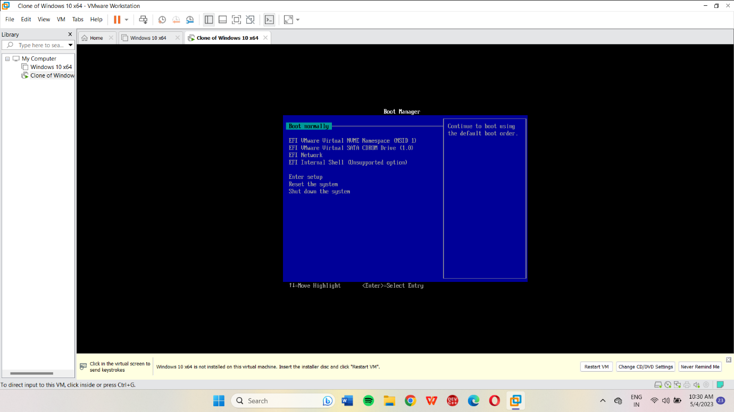

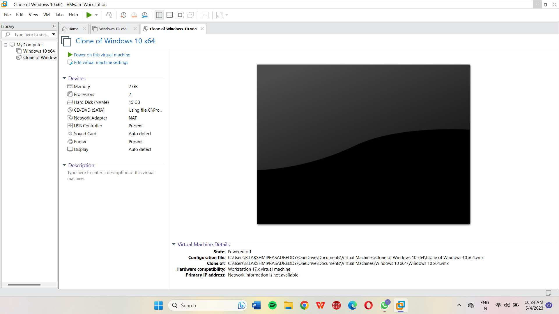

9. Create a Snapshot of a VM and Test it by loading the Previous Version/Cloned VM

**Solution:**

Snapshot of cloned VM:

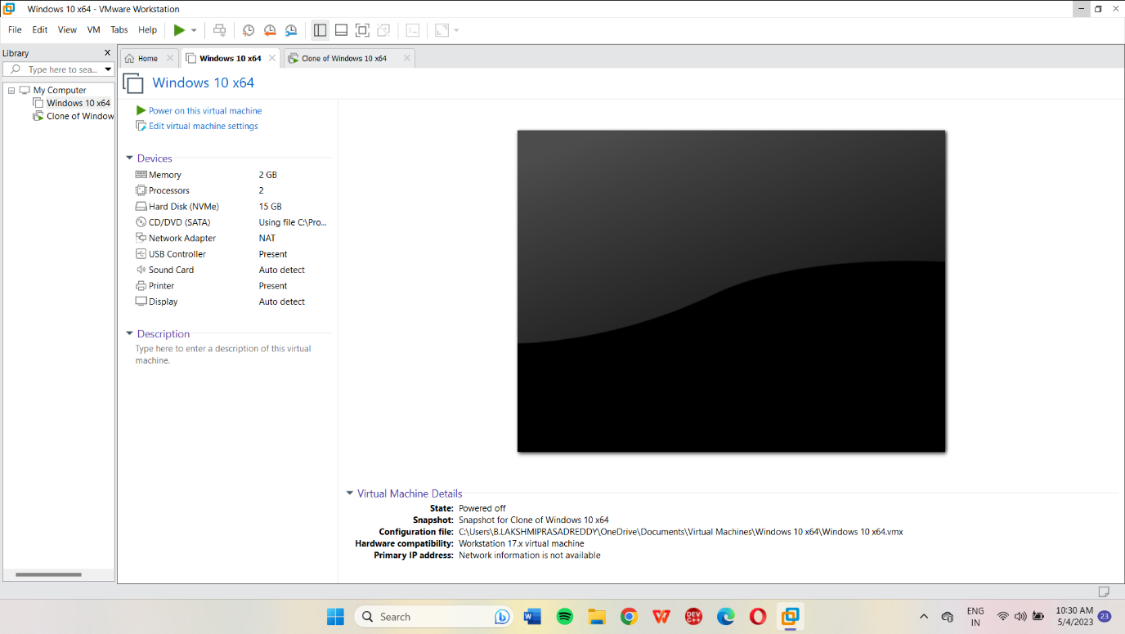

8. Create a Virtual Hard Disk and allocate the storage using VM ware Workstation

**Solution:**

Create virtual hard disk:

1. Open VMware Workstation on your host machine and select "Create a New Virtual Machine."
2. Select "Typical" and click "Next."
3. Choose the operating system you will be installing on the virtual machine and click "Next."
4. Enter a name for your virtual machine and choose a location to save it. Click "Next."
5. Specify the amount of memory (RAM) you want to allocate to the virtual machine and click "Next."
6. Select "Use bridged networking" if you want your virtual machine to be on the same network as your host machine. If you don't want to use bridged networking, select "Use network address translation (NAT)" and click "Next."
7. Choose "Create a new virtual disk" and click "Next."
8. Select "SCSI" as the disk type and click "Next."
9. Choose "Create a new virtual disk" and click "Next."
10. Specify the disk capacity and location where the virtual hard disk will be saved. Click "Finish."
11. Now you need to allocate the storage space to the virtual machine. To do this, click on "Settings" for the virtual machine you just created.
12. In the "Hardware" tab, click on the virtual hard disk that you just created, and then click "Expand."
13. Enter the new disk capacity, and then click "Expand" again to confirm.
14. Start the virtual machine and complete the operating system installation.

Result:

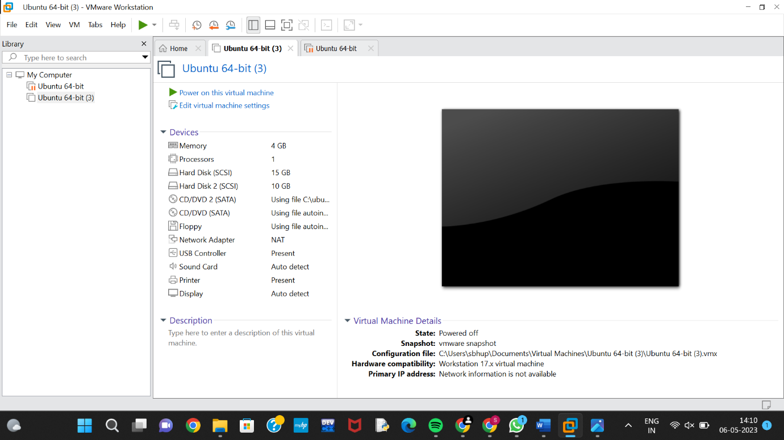

11)change hardware compatibility in of virtual machine

**Solution:**

Create a virtual machine:

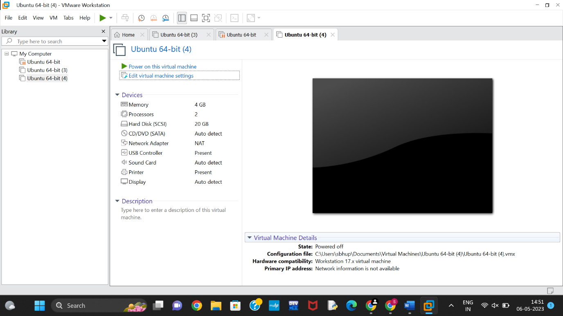

VM after changing compatibility:

